***Installation:***

*Prerequisites:*

*➔ 2 Linux Machines on AWS Ec2 Create 2 Ubuntu 20.04 EC2 instances on AWS and take remote access to them using SSH.*

*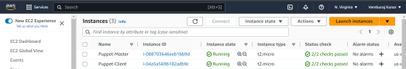Steps:*

*Follow instructions only on the mentioned machine(s)*

*1. On both master and client, Update Package List.*

*sudo apt-get update -y*

*2. On both master and client, set up the hostname resolution.*

*sudo nano /etc/hosts*

*Now, paste the following lines at the end of each file. These IP addresses are the Public IPv4 addresses of your instances. puppetmaster is your server and puppetclient is the client.*

*[puppet master ip] puppetmaster puppet*

*[puppet client ip] puppetclient*

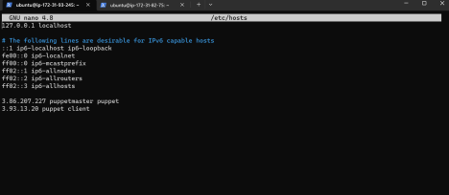

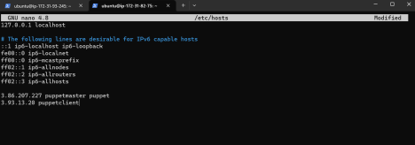

*Follow these instructions only on the master machine.*

*3. Download the latest Puppet Version*

*wget https://apt.puppetlabs.com/puppet6-release-focal.deb*

*4. Once the download is complete, install the package by using dpkg*

*sudo dpkg -i puppet6-release-focal.deb*

*5. Update the package repository:*

*sudo apt-get update -y*

*6. Install the puppet server.*

*sudo apt-get install puppetserver -y*

*Configuration:*

*7. Open the puppetserver file, under which you need to change the memory size from 2GB to 300MB since we don’t want it to overload our instance which has only 1 GB of RAM. sudo nano /etc/default/puppetserver*

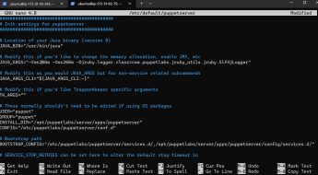

*8. Start and enable the Puppet Service*

*sudo systemctl restart puppetserver*

*sudo systemctl enable puppetserver*

*9. Verify the status of the service.*

*sudo systemctl status puppetserver*

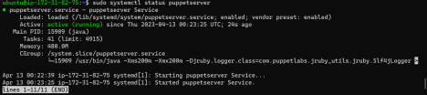

*Now that our server is up and running, let’s move to the client machine. Perform these commands only on the client machine.*

*10. Download the latest version of Puppet on the client.*

*wget https://apt.puppetlabs.com/puppet6-release-focal.deb*

*11. Once the download is complete, use dpkg to install the package.*

*sudo dpkg -i puppet6-release-focal.deb*

*12. Update the package repository again.*

*sudo apt-get update -y*

*13. Install the agent using -*

*sudo apt-get install puppet-agent -y*

*14. Start the puppet service and enable it -*

*sudo systemctl start puppet*

*sudo systemctl enable puppet*

*15. Check Puppet Service status*

*sudo systemctl status puppet*

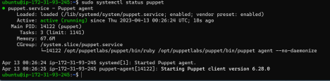

*Now that our server and puppet agent both are running, we can proceed to sign the Agent Certificate.*

*Perform these commands only on the master machine.*

*16. On the master node, list requested certificates*

*sudo /opt/puppetlabs/bin/puppetserver ca list*

*17. Once you spot the requested certificate from the client-side, you can sign it using - sudo /opt/puppetlabs/bin/puppetserver ca sign --all*

**

*18. To test the connection, you can use the following command*

*sudo /opt/puppetlabs/bin/puppet agent --test*

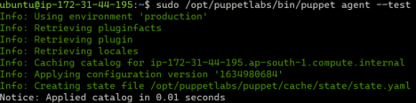

*If all went well, you’ll get the notice of applying catalog, which means that Puppet was configured properly on both machines.*